**Pattern Search using grep**

**1.Use any .c file. Using grep command extract and display**

**a.all lines beginning with #include with line numbers**

**Ans:**

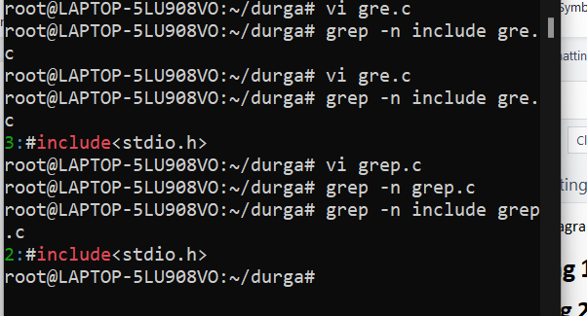

**b.display all lines which do not begin with #include**

**Ans:**

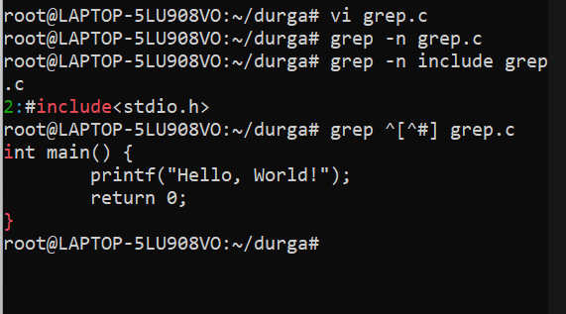

**c.display the line number of main()**

**Ans:**

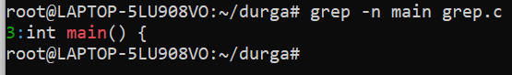

**d.extract all lines containing characters of opening and closing parathesis {(,))**

**Ans:**

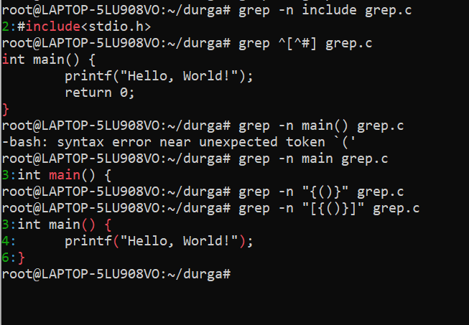

1. **Perform the above operations on a set of *.c files**

**Ans:**

